**Web Designing Assignment**

**Module (CSS and CSS 3) -2**

**1) What are the benefits of using CSS?**

**Ans.:**

1. CSS saves time you can write CSS once then same sheet in multiple HTMl pages
2. Faster page speed increases. More code means page speed can be slowed.
3. By using CSS you can control the color of text, the style of fonts, spacing between paragraphs
4. Incredes better user experience.

**2) What are the disadvantages of CSS?**

**Ans.:**

* Create confusion between web browsers.
* It can show different results in different browsers.
* After making changes we need to confirm carefully if it appears.

**3) What is the difference between CSS2 and CSS3?**

**Ans.:**

|  |  |
| --- | --- |
| * **CSS2** | * **CSS3** |
| * CSS2 is capable of positioning text and objects. | * CSS3 is capable of making the web page more attractive and takes less time to create. |
| * in contrast to CSS2, which consisted of a single document. | * CSS3 gas us uniqueness spits into many individual module, making CSS3 much easier to handle. |
| * CSS2 still has browser extension issues. | * CSS2 has complete support for almost all browser. |

1. **Name a few style components.**

**Ans.:**

1. Selecter: HTML elements name, id name, class name
2. Property: background color, font style, font size, position, text-align, color, border, background image.

**5) What do you understand by CSS opacity?**

**Ans.:** opacity is the degree to which content behind an element is hidden, and us the opposite of transparency. We can apply the opacity with difference styling properties to the elements.

**input:**

<!DOCTYPE html>

<html lang="en">

<head>

    <meta charset="UTF-8">

    <meta http-equiv="X-UA-Compatible" content="IE=edge">

    <meta name="viewport" content="width=device-width, initial-scale=1.0">

    <title>Document</title>

    <style>

        /* opacity css start */

        h1{

            background-color: cadetblue;

            opacity: 0.4;

        }

        h2{

            background-color: chocolate;

            opacity: 0.8;

        }

        h3{

            background-color: chocolate;

            opacity: 0.5;

        }

        /* opacity css end */

    </style>

</head>

<body>

    <!-- heading start -->

    <h1>this is title</h1>

    <h2>this is first paragraph</h2>

    <h3>this is second paragraph</h3>

    <!-- heading end -->

</body>

</html>

**Output:**

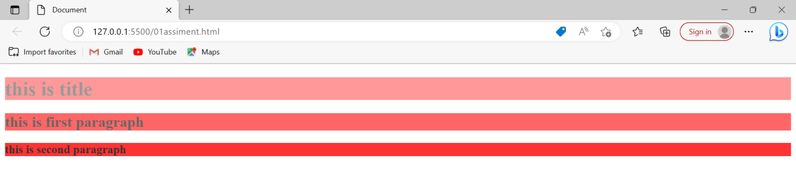

**6) How can the background color of an element be changed?**

**Ans.:**  To add background color in HTML, use the CSS background-color property. Set it to the color name or code name or code you want and place it inside a style attribute. Then add this style attributes to an HTML elements, like a table, heading, div, or span tag.

**Input:**

<!DOCTYPE html>

<html lang="en">

<head>

    <meta charset="UTF-8">

    <meta http-equiv="X-UA-Compatible" content="IE=edge">

    <meta name="viewport" content="width=device-width, initial-scale=1.0">

    <title>Document</title>

</head>

<body>

    <table border="1" style="background-color: yellow;">

    <tr style="background-color: red;">

        <td>5</td>

        <td>6</td>

        <td>7</td>

    </tr>

    <tr style="background-color: green;">

        <td>8</td>

        <td>9</td>

        <td>0</td>

    </tr>

    </table>

</body>

</html>

**OUTPUT:**

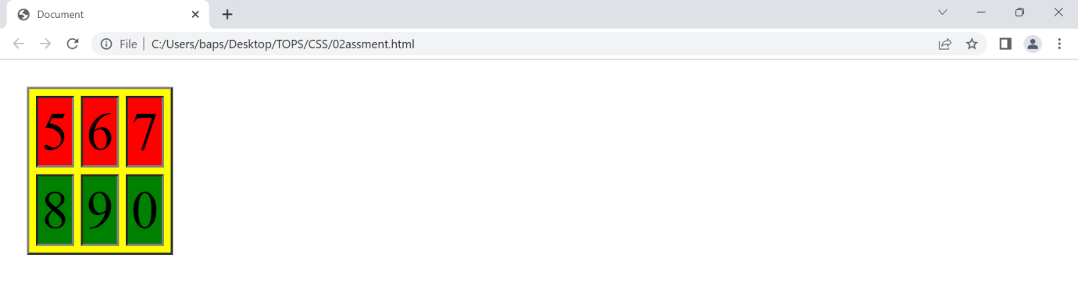

**7) How can image repetition of the backup be controlled?**

**Ans.** The background-repeat property id used to control the repetition of the image in the background. You can use a no-repeat value for the background-repeat property if you don’t want an image to repeat, in which case the image will be displayed only once.

* **Example**

<html>

<head>

<style>

Body{

Background-image:url();

/* background-repeat: no-repeat; */

Background-repeat: no-repeat;

</style>

</head>

<!-- body start -->

<body>

<!-- body end -->

</body>

</html>

**8) What is the use of the Background-position property?**

**Ans.** The background-position property sets the initial position of the background image. It use to set an image at a certain position. The position that is relative to the positioning layer, can be set by using the background origin property.

* **Example**

<title>background-position</title>

    <style>

     body{

        background-image: url(photo1.jpg);

        /* background-position */

        background-position:c center ;

         }

    </style>

</head>

         <body>

</body>

</html>

**9) Which property controls the image scroll in the background?**

**Ans.** To set the scrolling of an image in the background, use the background-attachment property. You can try to run the following code to learn how to work with the background-attachment property.

<Html>

<Style>

Body {

Background-image: url (imageone.jpg)

Background-repeat: no-repeat;

Background-attachment: fixed;

Background-attachment: scroll;

}

</style>

**10) Why should background and color be used as separate properties?**

**Ans.** There are two reasons behind this:

* It  enhances the legibility of style sheets. Background property is a complex property in CSS, and is  combined with color, the complexity will further increase.
* Color is an inherited property while the background  is not. So this can make confusion further.

**11) How to center  block elements using CSS1?**

**Ans.**

The properties margin-left and  margin-right can be set to auto and width to some specified value:

BODY {width:30em; background:cyan;}

* P{width:22em; margin-left:auto; ,argin-right:auto}

In this case, the left and right margins will each be four  ems wide, since they equally divide the remaining eight ems from (30em-22em).note that it is not  necessary to set an ecplicit width for the BODY element; it was done here to keep the math clean.

* Another example

Table {margin-left: auto; margin-right:auto; width:400px;}

In most legasy browsers, the width of a table is determined by default by its content. In CSS-compliant browsers, the full width of any element (including tables) defaults to the full width of its parent element’s content area. As browsers become more  compatible, authors will need to be aware of  the potential impact on their design.

**12) How to maintain the CSS specifications?**

**Ans.** The  specification also include:

The syntax and data types of  the language

Detailed explanation on CSS selectors

How you can assign values to properties

The Cascade (the “c” in CSS)

How inheritance works

The box model etc.

**13) What are the ways to integrate CSS as web page?**

**Ans.**

* Inline – by using the style attribute inside HTML elements
* Internal – by using a <style> element in the <head> section
* External – by using a <link> element to link to an external CSS files.
* **Inline CSS**

An inline CSS uses the style attribute of an HTML element.

* EXAMPLE

<html>

<body>

<h1 style= “color:black;”> heading </h1>

<p style= “color: green;”> paragraph</p>

</body>

</html>

* **Internal CSS**

An internal CSS is used to define a style for a single HTML page.

An internal CSS is defined in the <head> section of an HTML page,  within a <style>  element.

* EXAMPLE

<html>

<style>

Body {background-color:blue;}

h1 {color:blue;}

p {color: aqua;}

</style>

<body>

<h1> this is heading </h1>

<p> helloo world </p>

</body>

</html>

* **External CSS**

An external style sheet is used to define the style for many HTML pages.

* EXAMPLE

<html>

<head>

<link rel= “stylesheet” href= “style.css”>

</head>

<body>

<h1> heading</h1>

<p> paragraph</p>

</body>

</html>

The external style sheet can be written in any text editor. The file must not contain any HTML code, and must be saved with a .css extension.

“style.css” file look like

“style.css”

     body {

                 background-color: blue;

                }

      h1 {

             color: yellow;

           }

     p {

          color: green;

**14) What is embedded style sheets?**

**Ans.** Embedded stylesheet: it allows you to define styles for a particular HTML document as whole in one place. This id done by embedding the <style></style> tags containing the CSs properties in the head of your. Document.

* **Input**

<!-- embedded stylesheet start -->

<!DOCTYPE html>

<html lang="en">

<head>

    <meta charset="UTF-8">

    <meta http-equiv="X-UA-Compatible" content="IE=edge">

    <meta name="viewport" content="width=device-width, initial-scale=1.0">

    <title>Document</title>

    <!-- embedded stylesheet start -->

    <style>

        /* heading start */

        h1{

            font-size: larger;

            color: blueviolet;

            text-align: center;

        }

        /* content end */

        p{

            font-size: large;

        }

     </style>

</head>

<body>

    <!-- headingstart -->

    <h1>THIS IS A TITLE</h1>

    <!-- contectstart -->

    <p> this is first jenish</p>

    <p>this is secod jenish</p>

    <!-- content end -->

</body>

</html>

* **Output**

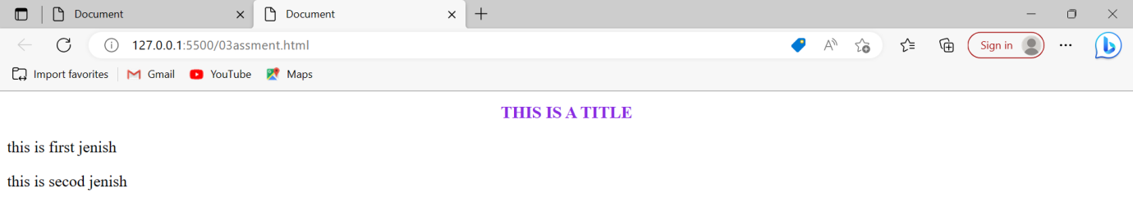

**15) What are the external style sheets?**

**Ans.**

An External style sheet is a separate CSS file that can be accessed by creating a link within the head section of the webpage. Multiple webpages can use the same link to access the stylesheet. The link to an external style sheet is placed within the head section of the page.

* **input**

<!DOCTYPE html>

<html lang="en">

<head>

    <meta charset="UTF-8">

    <meta http-equiv="X-UA-Compatible" content="IE=edge">

    <meta name="viewport" content="width=device-width, initial-scale=1.0">

    <title>Document</title>

    <link rel="stylesheet" href="style1.css">

</head>

<body>

    <!-- heading start -->

    <h1>Title</h1>

    <!-- heading end -->

    <!-- content start -->

    <p>Lorem ipsum dolor sit, amet consectetur adipisicing elit. Culpa eius sunt qui nemo non obcaecati itaque, sapiente

        reiciendis unde voluptatum illum minus amet corporis. Inventore veniam rem amet veritatis sequi.</p>

        <!-- content end -->

</body>

</html>

 EXTERNALFILE

h1{

    font-size: larger;

    text-align: center;

}

p{

    background-color: cadetblue;

    font-size: 10px;

}

* **output**

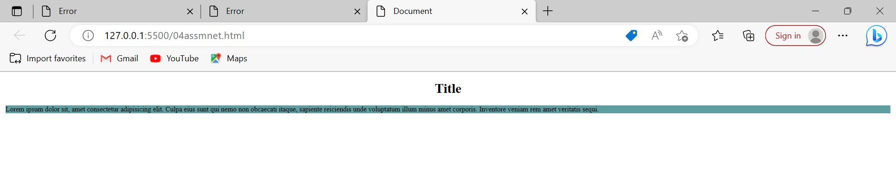

**16) What are the advantages and disadvantages of using external style sheets?**

**Ans.**

* **Advatages of external style sheet**

* Using them, the styles of multiple documents can be controlled from one file.
* Classes can be created for use on multiple HTML element types in many  documents.
* In complex situations , selector and grouping methods can be used to apply styles.
* **Disadvantages of external style sheet**
* In order to import style information for each document, an extra download is needed.
* Until the external style sheet is loaded, it may not be possible to render the document.
* For small number of style definitions, it not viable.

**17) What is the meaning of  the CSS selector?**

**Ans.** CSS selector are  used to “find” or select the HTML elements you want to style.

* CSS element selector
* CSS id class selector( to call id selector “#”)
* CSS class selector ( to call class selector “.”)
* CSS universal selector (to call universal selector “*”)
* CSS group selector ( to call group selector “h1,h2”)

**18) What are the media types allowed by CSS?**

**Ans.** CSS –media one of the most important feature of style sheets is that they specify how a document is to be presented on different media: on the screen, on the screen, paper, with a speech synthesizer, with a Braille device.

* The media types are
* For mobile: 320px to 480px
* For tablets,i-pad: 481px to  768px
* For for small screen,laptop: 769px to 1024px
* For desktop,large screen: 1025px to 1200px
* For extra large screen,tv : 1201px to more
* **Example :**

@media (min-with:320px) and (max-width:480px){ }

**19) What is the rule set?**

**Ans.** A CSS rule set contains one or more selectors and one  or more declarations. The selector(S),which in this example is h1,points to an HTML elements. The declatation(S), which in this example are color: red and text-align: center style the element with a property and value. The rule set is the main building block of a CSS sheet.

h1 {

 color : red;

text-align: center;

}

**20) Create Layout**

**Ans. Input:**

<!DOCTYPE html>

<html lang="en">

<head>

  <meta charset="UTF-8">

  <meta http-equiv="X-UA-Compatible" content="IE=edge">

  <meta name="viewport" content="width=device-width, initial-scale=1.0">

  <title>Document</title>

  <style>

    /* main */

    #main {

      height: 500px;

      width: 100%;

      background-color: white;

      padding: 20px;

    }

    /* main1 */

    #main1 {

      height: 250px;

      width: 100%;

      background-color: white;

      display: flex;

      padding: 10px;

    }

   /* box one */

    #one {

      height: 250px;

      width: 33.33%;

      background-color: white;

      padding: 20px;

    }

     /* boxone1 */

    #one1 {

      height: 125px;

      width: 100%;

      background-color: gray;

    }

    /* box one2 */

    #one2 {

      height: 125px;

      width: 100%;

      background-color: white;

      text-align: center;

 }

     /* box2 */

    #two {

      height: 250px;

      width: 33.33%;

      background-color: white;

      padding: 20px;

       }

    /* box two1 */

    #two1 {

      height: 125px;

      width: 100%;

      background-color: gray;

   }

     /* box two2 */

    #two2 {

      height: 125px;

      width: 100%;

      background-color: white;

      text-align: center;

     }

    /* box  three */

    #three {

      height: 250px;

      width: 33.33%;

      background-color: white;

      padding: 20px;

    }

      /* box three1 */

    #three1 {

      height: 125px;

      width: 100%;

      background-color: gray;

 }

      /* box three2 */

    #three2 {

      height: 125px;

      width: 100%;

      background-color: white;

      text-align: center;

    }

     /* main2 */

    #main2 {

      height: 250px;

      width: 100%;

      background-color: white;

      display: flex;

      padding: 10px;

 }

      /* box four */

    #four {

      height: 250px;

      width: 33.33%;

      background-color: white;

      padding: 20px;

   }

      /* box four1 */

    #four1 {

      height: 125px;

      width: 100%;

      background-color: gray

    }

       /* box four2 */

    #four2 {

      height: 125px;

      width: 100%;

      background-color: white;

      text-align: center;

    }

     /* box five */

    #five {

      height: 250px;

      width: 33.33%;

      background-color: white;

      padding: 20px;

    }

      /* box five1 */

    #five1 {

      height: 125px;

      width: 100%;

      background-color: gray

    }

       /* five2 */

    #five2 {

      height: 125px;

      width: 100%;

      background-color: white;

      text-align: center;

    }

       /* box six */

    #six {

      height: 250px;

      width: 33.33%;

      background-color: white;

      padding: 20px;

    }

       /* box six1 */

    #six1 {

      height: 125px;

      width: 100%;

      background-color: gray

    }

      /* box six2 */

    #six2 {

      height: 125px;

      width: 100%;

      background-color: white;

     }

  h1 {

      margin-left: 120px;

      padding-top: 50px;

      font-size: small;

    }

    p{

      padding-right: 150px;

    }

  </style>

</head>

<body>

  <!-- main start -->

  <div id="main">

    <div id="main1">

      <div id="one">

        <div id="one1">

          <h1>

            <font color="white">Thambnail</font>

          </h1>

        </div>

        <div id="one2" > this is a wider card with supporting text  <br> balow as a natural lead in to additional <br> content. this

          content is a little bit longer.

          <br>

<p> <button>View</button>

          <button>Edit</button></p>

        </div>

      </div>

      <div id="two">

        <div id="two1">

          <h1>

            <font color="white">Thambnail</font>

          </h1>

        </div>

        <div id="two2"> this is a wider card with supporting text   <br>  balow as a natural lead in to additional   <br>  content. this

          content is a little bit longer

          <br>

         <p> <button>View</button>

          <button>Edit</button></p>

        </div>

      </div>

      <div id="three">

        <div id="three1">

          <h1>

            <font color="white">Thambnail</font>

          </h1>

        </div>

        <div id="three2"> this is a wider card with supporting text  <br>  balow as a natural lead in to additional <br> content.

          this content is a little bit longer

          <br>

         <p> <button>View</button>

          <button>Edit</button></p>

        </div>

      </div>

    </div>

    <div id="main2">

      <div id="four">

        <div id="four1">

          <h1>

            <font color="white">Thambnail</font>

          </h1>

        </div>

        <div id="four2"> this is a wider card with supporting text  <br> balow as a natural lead in to additional  <br> content.

          this content is a little bit longer

          <br>

         <p><button>View</button>

          <button>Edit</button></p>

        </div>

      </div>

      <div id="five">

        <div id="five1">

          <h1>

            <font color="white">Thambnail</font>

          </h1>

        </div>

        <div id="five2"> this is a wider card with supporting text <br> balow as a natural lead in to additional  <br>content.

          this content is a little bit longer

          <br>

        <p> <button>View</button>

          <button>Edit</button></p>

  </div>

      </div>

      <div id="six">

        <div id="six1">

          <h1>

            <font color="white">Thambnail</font>

          </h1>

        </div>

        <div id="six2"> this is a wider card with supporting text <br> balow as a natural lead in to additional <br> content. this

          content is a little bit longer

          <br>

 <p><button>View</button><button>Edit</button></p>

  </div>

      </div>

    </div>

  </div>

</body>

</html>

**Output :**

